CSCI P 565 - SOFTWARE ENGINEERING 1

ITERATION 3 USER STORY 3.7 – QUALITY ASSURANCE

Bicycle 10:

Gautam Poornachandra

Aishwarya Iyer

Manasa Patibandla

Kamalkanth Chowdary Adusumilli

We have performed quality assurance on bicycle 3’s project. We thank them for their time and cooperation.

Bicycle 3:

Varun Nadkarni

Pranay Sogani

Aamin Lakhani

Abhishek Datar

After checking the code and functionality of their application – Household Chores, we have identified 3 bugs.

Bug 1 – Design flaw in create task implementation.

Bug 2 - Sign up form does not retain details given by user on homepage when user enters incorrect details.

Bug 3 – Inconsistent error display mechanism.

**Bug 1: Design flaw in Create Task implementation:**

When a user wants to create a new task, he clicks on create task tab on the dashboard. Then a panel is loaded. The user specifies the start date, then the user is prompted to select a date in the week. This is shown in the screenshot below:

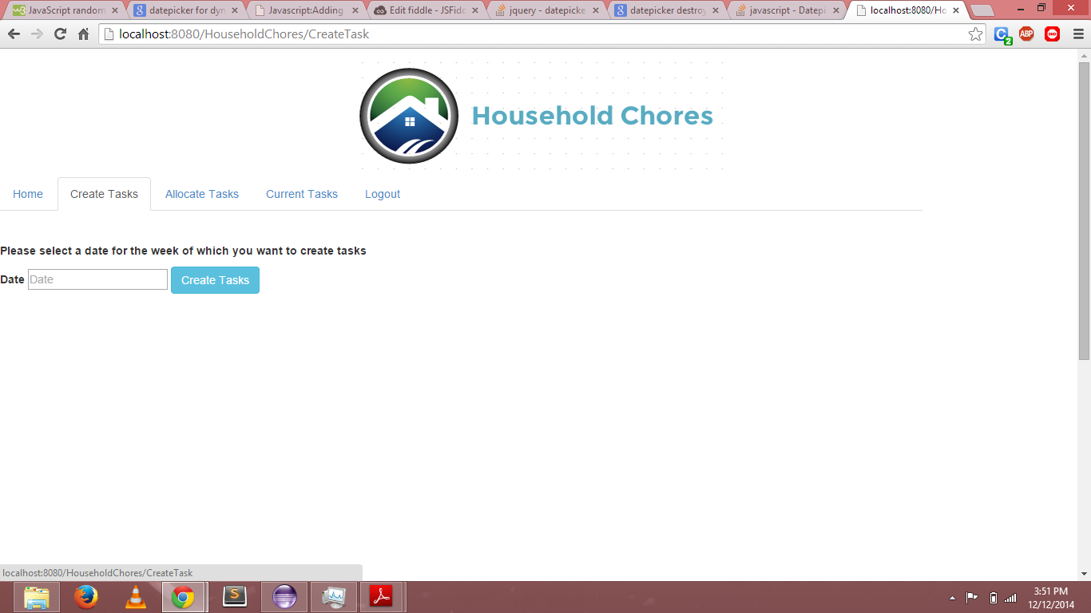

When user selects a date and clicks on create tasks, another panel with fields to specify task details is created. This is shown in the screenshot below:

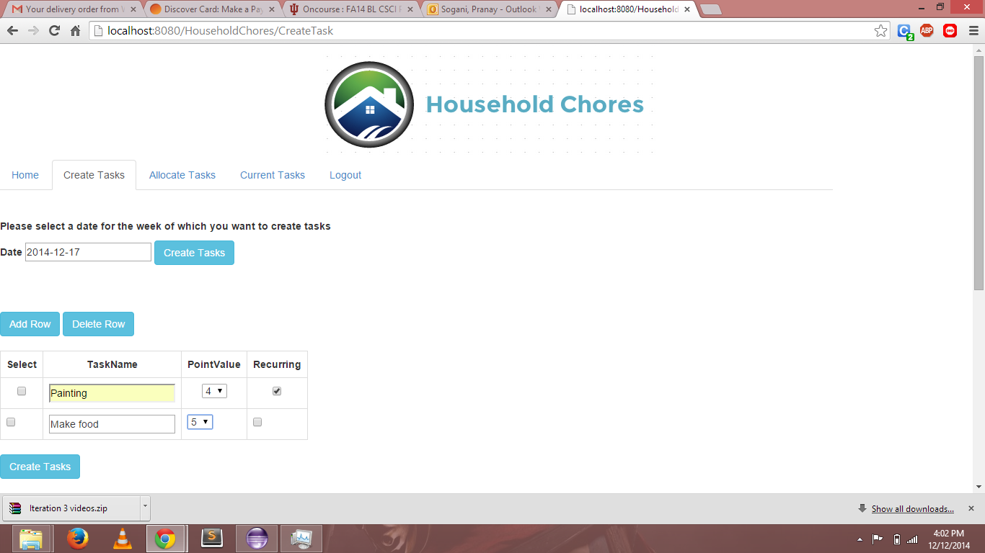

**Design Flaw:**

User can create multiple tasks with the same start date using their design. If a user wants to create a new task with a different start date, he has to go back (again click on create task tab every time to create a new task) and change the date and then create a task.

**Bug 2: Sign up form does not retain details given by user on homepage:**

When a user signs up for the first time to use the application, he is prompted to give his/her details to create an account. This is shown in the screenshot below:

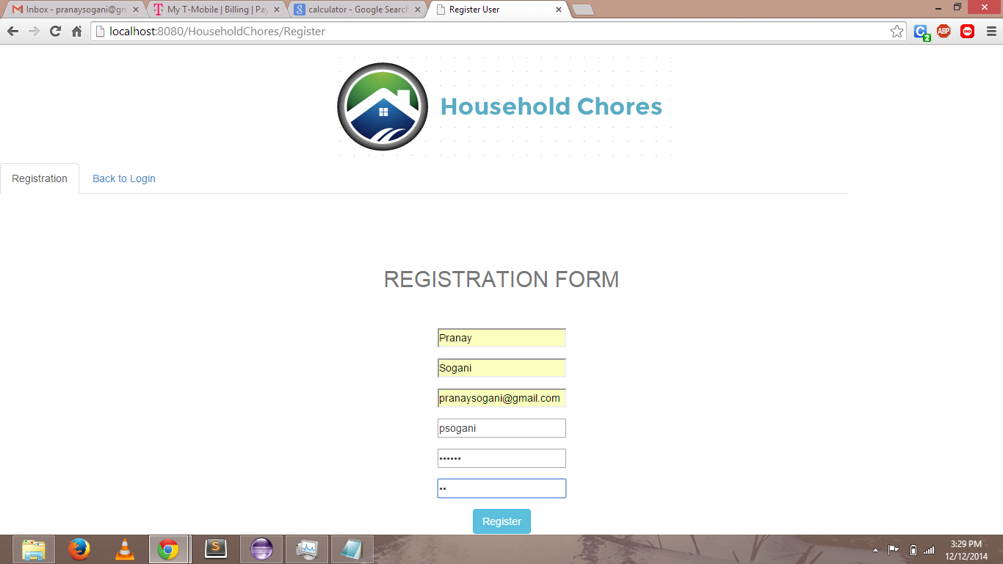

If the user enters incorrect password in the reenter password field, an error is thrown as shown below:

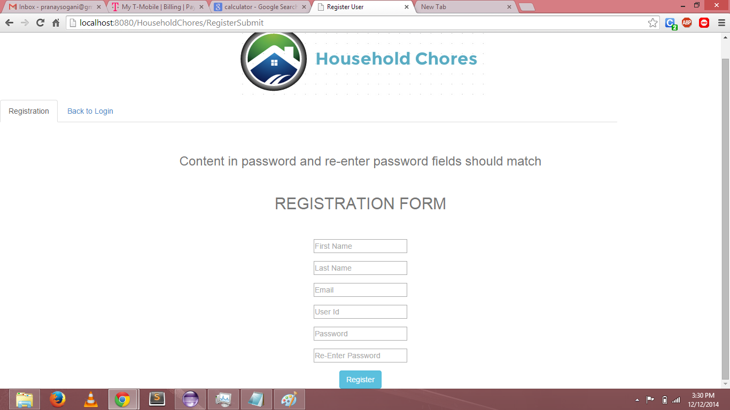

**Bug:** When the user gives an incorrect password in the reenter password field, the entire page is refreshed without storing the valid details in the form. The user has to give all his details again in order to register.

**Ideal design:**

When the user gives a wrong password in the re-enter password field, an error has to be thrown – “the password in re-enter password field does not match with the password given”. All the other valid details should be saved in the form (only the value in the re-enter password field has to be deleted). To register, the user has to just enter the correct password in the re-enter password field instead of entering all the details.

**Bug 3 – Inconsistent error display mechanism:**

When the user gives different passwords in password and re-enter passwords field, an error is thrown. It is shown in the screenshot below:



When another error occurs, for example let’s consider the case of task allocation. User picks up a task and clicks allocate task button without selecting an assignee. Then the error is thrown in the form of an alert box as shown below. Earlier the error was displayed in the form of text on the webpage.

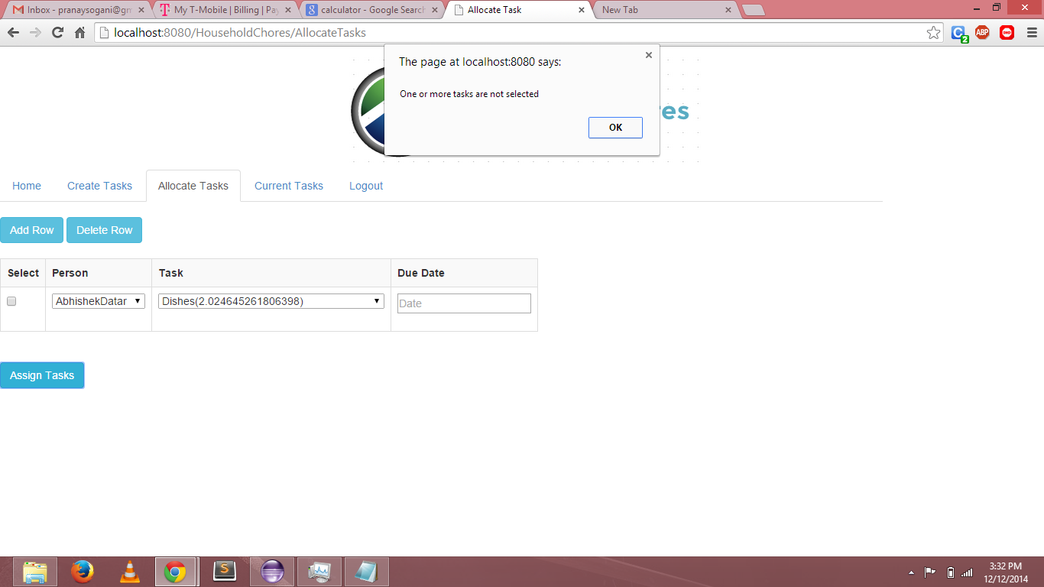

**Bug:** The errors should be displayed in the same manner throughout the application to ensure consistency and ease of use for the users. This has to be addressed by making minor changes to the design.